Directions:
Using the installation manual of the unit you are working on, determine the option setting (segment 2), segment number and value you need to adjust to configure the system. As you work through the option setting pages in the manual, fill in the value of the segments you wish to change. In chart 1.
Once you have all the segments for each page configured create the code using figure 1.
Now that you have created the code, you will need to program it into the unit. If you are using a handheld controller, use chart 2 below. Fill in each segment value for the code. Use this chart to help program the controller. The handheld controller’s display should correspond to the setting in chart #2. Once the code is entered into the controller point the controller at the indoor unit and press the power button.
If you require further assistance, please contact your Regional Technical Services Manager.
Chart 1
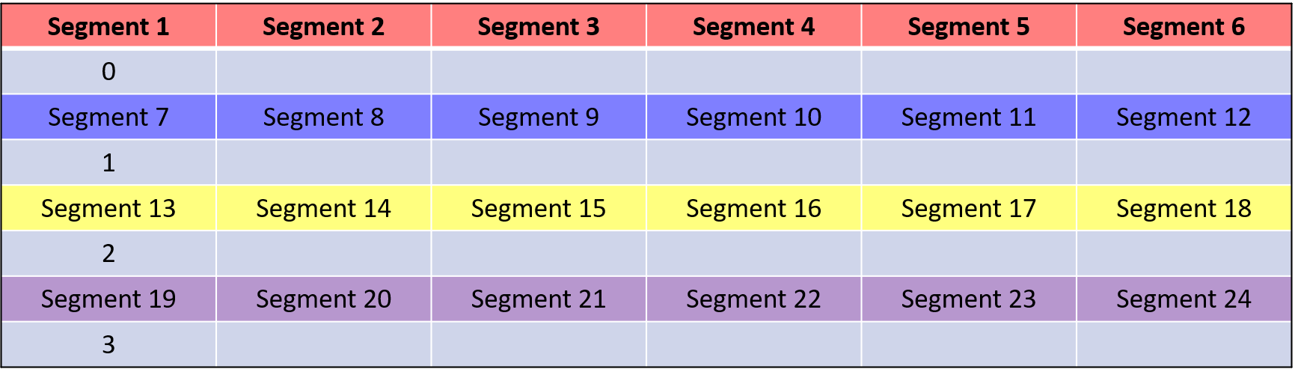
Figure 1
Chart 2
on
Auto
Seg 2 Seg 3
on
Cool
on
Dry
on
Fan
on
Heat
Off
Auot
Cool
Dry
Fan
Heat
Off
Off
Off
Off
Seg 4 Seg 5
Seg 6 Seg 8
Seg 9 Seg 10
Seg 11 Seg 12
Seg 14 Seg 15
Seg 16 Seg 17
Seg 18 Seg 20
Seg 21 Seg 22
Seg 23 Seg 24
0_____-1_____-2_____-3_____
1 2 3 4 5 6 7 8 9 10 11 12 13 14 15 16 17 18 19 20 21 22 23 24

